**VOCABULARY QUIZ**

**Answer the following questions based on “Mera Joota Hai Japani”:**

1. What does हैरानी mean?

Meaning: ___________

Did you know the meaning of the word before listening to the song? Yes No

2. What does मौत mean?

Meaning: ___________

Did you know the meaning of the word before listening to the song? Yes No

3. What does रूसी mean?

Meaning: ___________

Did you know the meaning of the word before listening to the song? Yes No

4. What does बिगडे mean?

Meaning: ___________

Did you know the meaning of the word before listening to the song? Yes No

5. What does तूफानी mean?

Meaning: ___________

Did you know the meaning of the word before listening to the song? Yes No

6. In the following sentence what does मंजिल mean?

मेरा घर दो मंज़िल है और मैं पहली मंज़िल पर रहती हु ।

Meaning: ___________

Did you know the meaning of the word before listening to the song? Yes No

7. In the following sentence what does मंजिल mean?

मेरे जीवन का मंज़िल डॉक्टर बनना और लोगों की मदद करना है।

Meaning: ___________

Did you know the meaning of the word before listening to the song? Yes No

8. In the following sentence what does निशानी mean?

मंगलसूत्र भारत में एक विवाहित महिला की निशानी है

Meaning: ___________

Did you know the meaning of the word before listening to the song? Yes No

9. In the following sentence what does उपरवाला mean?

उपरवाले ने आदमी का सुख दुःख,मरना जीना सब अपने हाथ में रखा है।

Meaning: ___________

Did you know the meaning of the word before listening to the song? Yes No

10. In the following sentence what does शहज़ादे mean?

अकबर के शहज़ादे जहांगीर की शादी नूरजहा से हुई थी।

Meaning: ___________

Did you know the meaning of the word before listening to the song? Yes No

1. Write a word for the given picture below



Meaning: ___________

Did you know the meaning of the word before listening to the song? Yes No

1. Write a word for the given picture below



Meaning: ___________

Did you know the meaning of the word before listening to the song? Yes No

1. Write a word for the given picture below



Meaning: ___________

Did you know the meaning of the word before listening to the song? Yes No

1. Write a word for the given picture below

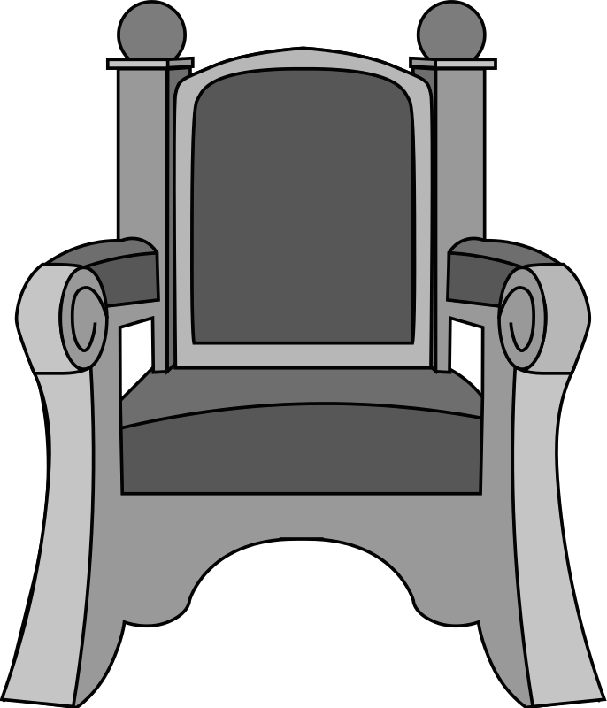

Meaning: ___________

Did you know the meaning of the word before listening to the song? Yes No

1. Write a word for the given picture below



Meaning: ___________

Did you know the meaning of the word before listening to the song? Yes No

1. Write a word for the given picture below



Meaning: ___________

Did you know the meaning of the word before listening to the song? Yes No

1. Write a word for the given picture below



Meaning: ___________

Did you know the meaning of the word before listening to the song? Yes No

1. Write a word for the given picture below



Meaning: ___________

Did you know the meaning of the word before listening to the song? Yes No

1. Write a word for the given picture below



Meaning: ___________

Did you know the meaning of the word before listening to the song? Yes No

1. Write a word for the given picture below



Meaning: ___________

Did you know the meaning of the word before listening to the song? Yes No

**Answer the following questions based on “Lakshya”:**

1. What does परबत mean?

Meaning: ___________

Did you know the meaning of the word before listening to the song? Yes No

2. What does अम्बर mean?

Meaning: ___________

Did you know the meaning of the word before listening to the song? Yes No

3. What does नाग mean?

Meaning: ___________

Did you know the meaning of the word before listening to the song? Yes No

4. What does लक्ष्य mean?

Meaning: ___________

Did you know the meaning of the word before listening to the song? Yes No

5. What does टकराए mean?

Meaning: ___________

Did you know the meaning of the word before listening to the song? Yes No

6. In the following sentence what does फ़ासलेmean?

मेरा विद्यालय मेरे घर से थोड़े ही फ़ासले पर है।

Meaning: ___________

Did you know the meaning of the word before listening to the song? Yes No

7. In the following sentence what does क़दमों mean?

बच्चे अपने माँ बाप के क़दमों पर चलते है।

Meaning: ___________

Did you know the meaning of the word before listening to the song? Yes No

8. In the following sentence what does आँधी mean?

आँधी में बहुत तेज़ हवा चलती है।

Meaning: ___________

Did you know the meaning of the word before listening to the song? Yes No

9. In the following sentence what does ताक़त mean?

जंगल का राजा, शेर बहुत ताक़तवर होता है ।

Meaning: ___________

Did you know the meaning of the word before listening to the song? Yes No

10. In the following sentence what does लिपटे mean?

सर्दी में मैं कम्बल में लिपटे सो जाती हूँ।

Meaning: ___________

Did you know the meaning of the word before listening to the song? Yes No

**FEEDBACK QUESTIONNAIRE**

**Rate the two tools used from 1-5.**

1. How easy was the tool for language learning?
   1. Smart Indic Lyrics: ____
   2. Dual Lyrics: ____
2. How enjoyable was the tool for language learning?
   1. Smart Indic Lyrics: ____
   2. Dual Lyrics: ____
3. Rate your overall understanding of the song using
   1. Smart Indic Lyrics: ____
   2. Dual Lyrics: ____